**The history of tea**

BC 20,000 : The wild tea plant have been grown in the high mountain area, from India to southern China

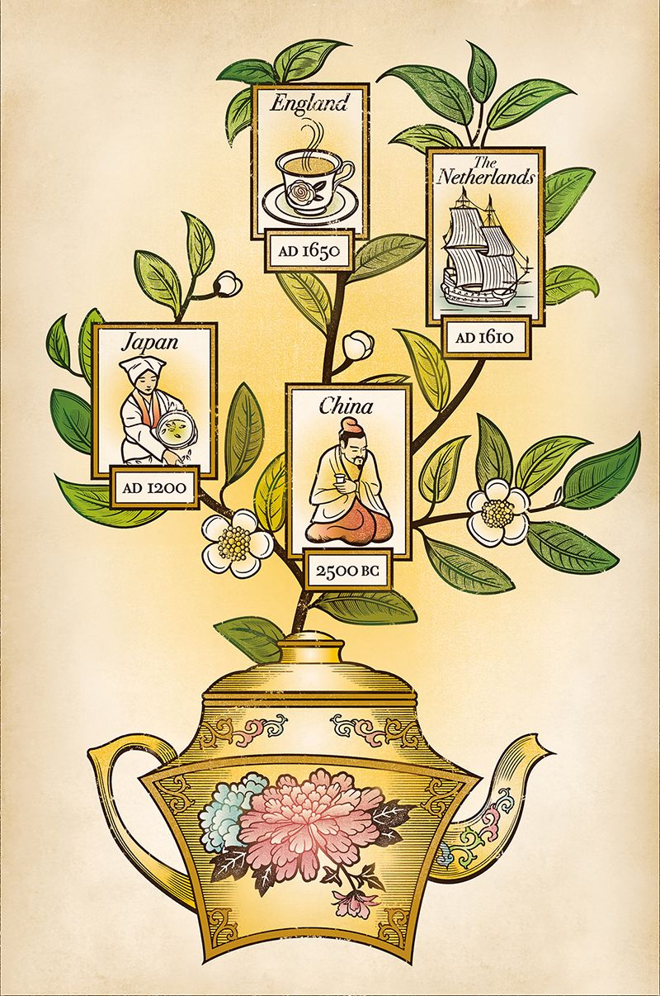BC770 China : Chinese god of farming and medicine, Shen-nong, is said to live on the tea and vegetable.

BC 100’s China : The book, “Shen-nong Ben Cao Jing”, Vegetation and Pharmacy Sutra of Shen-nong, introduced tea as medicine.

760 China : The book of “the classic of Tea”, Tea sutra, of Rikuu, a Chinese writer. They drank cake tea.

1214 Japan : Zen buddhism monk, Eisai, brought tea and tea tree, from China to Japan.

Zen school monks drank dried leaf green tea in this period for meditation.

1500’s Japan : Development of tea-ceremony, “Cha no Yu”.

Sen-no Rikyu established tea-ceremony.

They drank powder tea, “Maccha”. 3 schools of tea-ceremony, Omote Senke, Ura Senke and Mushano-koji Senke, have divided from Rikyu.

1610-1650’s : Black tea was introduced to Netherland and England.

1652 Yamada Souhen, established Souhen Ryu “宗偏流” school of tea-ceremony.

**Tea and Medicine**

Tea was introduced to Japan with Buddhism as the high technology medicine of developed country. Drinking tea was a kind of medical treatment and processed with careful control of hygiene. Actually the manners of tea-ceremony remains the resemblance to sterile operation.

For example,

･ Making tea just beside the burner, to prevent the falling down of bacteria.

･ Sterilize cup with boiled water.

･ Prevent direct touch of finger to the cup and tea powder as far as possible.

･ Use of hermetic bottle of tea container(Cha-ire), spatel(Cha-saji) and gauze(Cha-kin).

**How to drink Maccha Tea(Simple way)**

1. Have some sweets at first.

2. Hold the served tea cup with both hands.

3. Rotate the cup clockwise to avoid Front face.

4. Drink tea with 3 and half sipping.

5. Rotate the cup counter-clockwise.

6. Most important point is “Just Enjoy”, because

welcoming the guest is the spirit of tea-ceremony.

**The route from Seikei Univ. to Tokai Univ. campus.**

1. Via Shibuya

Seikei Front gate, Bus stop. Bus Kichijoji STA.

Kichijoji STA. Chuou Line(Orange) Yotsuya STA.

Yotsuya STA. Nanboku Metro(Dark Green) ShiroganeTakanawa STA.

ShiroganeTakanawa STA. 15 min. walk to Tokai Univ.

2. Via Yotsuya

Seikei Front gate, Bus stop. Bus Kichijoji STA.

Kichijoji STA. Inoagshira Line Shibuya STA.

Shibuya STA. Yamanote Line(Green) Shinagawa STA.

ShiroganeTakanawa STA. 15 min. walk to Tokai Univ.

Takanawa Shirogane STA. > Tokai Univ.

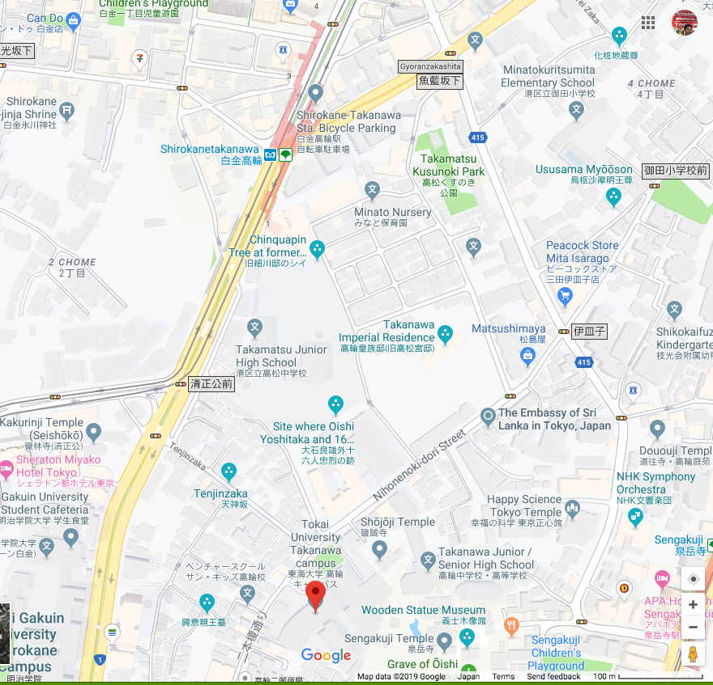

Shinagawa STA. > Tokai Univ.

